|  |  |  |  |  |
| --- | --- | --- | --- | --- |
| **School of Electronics Engineering (SENSE)** | | | | |
| **J COMPONENT – REPORT** | | | | |
| **COURSE CODE / TITLE** | BECE204L – MICROPROCESSORS & MICROCONTROLLERS | | | |
| **PROGRAM / YEAR/ SEM** | B.Tech II Year/ FALL 2023-2024 | | | |
| **LAST DATE FOR REPORT SUBMISSION** | 23-11-2023 | | | |
| **DATE OF SUBMISSION** | 23-11-2023 | | | |
| **TEAM MEMBERS**  **DETAILS** | **REGISTER NO.** | | **NAME** | |
| 22BCE1545 | | ATCHAYA M | |
| 22BCE1656 | | AMITH S | |
| 22BCE1715 | | HARISANKAR R NAIR | |
| 22BCE1827 | | B NANDHITHA | |
| **PROJECT TITLE** | **Gesture Enabled Door Access System** | | | |
| **COURSE HANDLER’S NAME** | **DR.N.SUBHASHINI** | **REMARKS** | |  |
| **COURSE HANDLER’S SIGN** |  |

**OBJECTIVE:**

The objective of this project is to develop a secure and convenient way to access a door by using hand gestures as a form of authentication using PAJ7620 and Arduino Uno. The system aims to provide an alternative to traditional key-based and electronic keycard door locks, offering a more intuitive and user-friendly method of entry while maintaining high levels of security.

**BLOCK DIAGRAM:**

(Give the BLOCK diagram of your project)

**COMPONENTS/ SOFTWARE REQUIRED:**

|  |  |  |
| --- | --- | --- |
| Component/Software | Quantity | Purpose |
| Arduino Uno | 1 | Microcontroller used |
| PAJ7620 Sensor | 1 | Humidity Sensor |
| 16x2 LCD Interface | 1 | Display Real-time Data |
| Breadboard | 1 | Used for prototyping and testing electronic circuits |
| Jumper Wires | As Required (around 20) | Connection Between Parts |
| Arduino IDE(Software) | - | Programming the Arduino |

**PROJECT DESCRIPTION:**

Circuit of this project contains Arduino, gesture sensor and LCD. The function of the Arduino in the "Hand Gesture-Enabled Door Access Control System" is to process data from the gesture recognition algorithm, make access control decisions based on recognized gestures, and manage communication with the door lock mechanism. Gesture sensor is used to recognize and process the user’s hand gestures. LCD is used for displaying status or messages on it.

* The system captures hand gestures through the sensor and processes the data with a gesture recognition algorithm.
* The Arduino microcontroller analyzes the recognized gestures, makes access control decisions, and manages communication with the door lock mechanism.
* Based on the analysis, the door lock mechanism is activated, granting or denying access to the secured area.

**PAJ7620 Gesture Recognition Sensor**

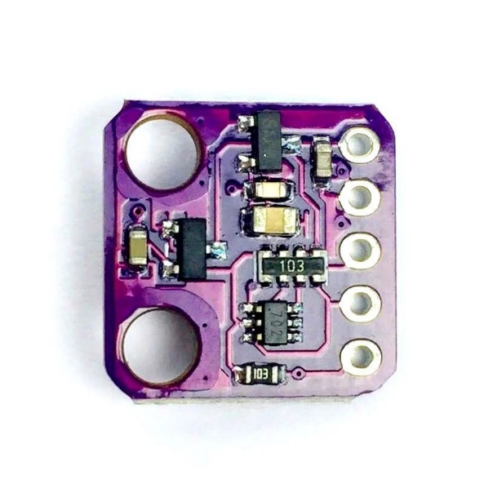

PAJ7620U2 integrates gesture recognition function with general I2C interface into a single chip. It can recognize 9 gestures and the gesture information can simply access via the I2C bus.

Gesture recognition function:

* Move up
* Move down
* Move left
* Move right
* Move forward
* Move backward
* Circle-clockwise
* Circle-counter clockwise
* Wave

Mechanism:

The PAJ7620 sensor emits infrared light and detects the reflection of this light off objects, such as a hand. It has an array of photodiodes that measure the intensity of the reflected light.

By analysing the pattern of these intensities, the sensor can recognize various gestures, such as swipes, circles, and waves. Once a gesture is recognized, the sensor generates an output signal, which can be used by a microcontroller to perform specific tasks based on the gesture.

* Step 1: Infrared Emission
* Step 2: Reflection Detection
* Step 3: Light Detection
* Step 4: Pattern Recognition
* Step 5: Gesture Recognition
* Step 6: Output Signal
* Step 7: Integration with Microcontroller

**CONCEPT LEARNED:**

(List out the main concept you have learned from this project)

**IMPLEMENTATION:**

(Provide the photographs of developed prototype model of your projects under different working condition or scenario. Give a short description under the photograph for all pictures and also provide the YouTube link for your project demo)

**CHALLENGES FACED:**

(List out various challenges or difficulties faced while implementing your project)

**APPLICATIONS:**

This project has applications on multiple other domains:

1. Office Security System:

Implement the gesture recognition system for securing office spaces or confidential areas. Employees or authorized individuals can use predefined gestures to gain access.

1. Vehicle Security:

Integrate the gesture recognition system into vehicles as an additional layer of security. Authorized users can perform specific gestures to unlock or start the vehicle.

1. Healthcare Access Control:

Use the gesture-based door lock in healthcare settings where access control is crucial. Medical professionals can use gestures to access restricted areas containing sensitive patient information or medical supplies.

1. Smart Cabinets or Lockers:

Apply the gesture recognition system to secure cabinets or lockers storing valuable items. Users can use gestures instead of traditional keys or combinations to unlock and access their belongings.

1. Presentation Control:

Utilize the gesture recognition system during presentations. Speakers can use gestures to control slides, start/stop videos, or interact with multimedia content without the need for a remote control.

**CONCLUSION:**

In conclusion, the dynamic gesture recognition door lock project redefines security with a futuristic touch. Using the PAJ7620 sensor and Arduino, it introduces an engaging and adaptable method for access control. The project's versatility spans various environments, emphasizing its human-centric design. Customizable gesture sequences open doors to diverse applications, while its robust security features, including limited attempts and real-time alerts, enhance protection. Beyond security, the project pioneers accessibility for individuals with physical disabilities. Through visual cues on the LCD display, it engages users and serves as a beacon at the intersection of innovation and practicality. This project is a glimpse into a future where gesture-based interfaces seamlessly integrate technology into our lives in exciting and empowering ways.